Project Design Phase
Problem – Solution Fit Template

Date | 18th June 2026
Team ID
Project Name | Health Connect
Maximum Marks | 2 Marks

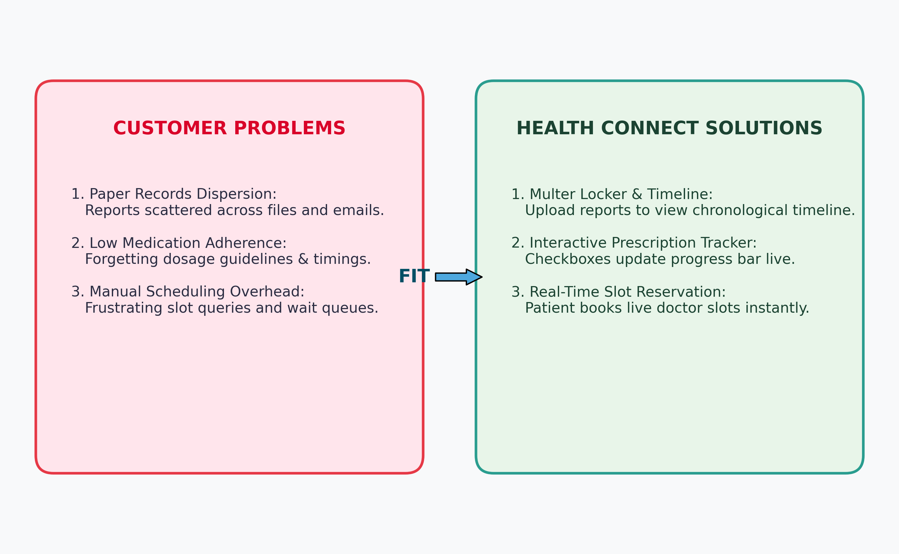
The Problem-Solution Fit simply means that you have found a problem with your customer and that the solution you have realized for it actually solves the customer’s problem. It helps entrepreneurs, marketers and corporate innovators identify behavioral patterns and recognize what would work and why
Purpose:
- Solve complex problems in a way that fits the state of your customers.
- Succeed faster and increase your solution adoption by tapping into existing mediums and channels of behavior.
- Sharpen your communication and marketing strategy with the right triggers and messaging.
- Increase touch-points with your company by finding the right problem-behavior fit and building trust by solving frequent annoyances, or urgent or costly problems.
- Understand the existing situation in order to improve it for your target group.

Template:

## Problem-Solution Fit Matrix for Health Connect
User Segment | Identified Problem | Health Connect Solution
Patient | Losing physical medical records and forgetting medication times. | Secure local file uploading (Multer) displayed on a chronological timeline; interactive prescription checkboxes with a visual progress bar.
Doctor | Lack of patient history and manual scheduling. | Access to the patient's shared chronological health timeline; online slot management and instant dashboard bookings.
Admin | Verifying doctor registrations and monitoring platform metrics. | Admin control console to approve pending doctors and dynamic platform analytics using Chart.js.

